**IT24100754**

**Dilanya A.N.G.A**

**PS Lab Sheet 05**

**Exercise**





2.

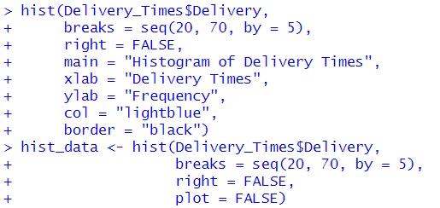

3.

4.



